Ýmir Þórleifsson

HW 7

# 7.1.1

(p,w):(0,0). P1=Page fault. P2=6

(p,w):(0,1). P1= .Page fault P2=15.

(p,w):(1,0). P1= 9. P2=Page fault.

(p,w):(1,1). P1=-3. P2=Page fault.

(p,w):(2,0). P1=0. P2=5.

(p,w):(2,2). P1=2. P2=-3.

(p,w):(3,0). P1=Page fault. P2=error.

(p,w):(3,3). P1=15. P2=error.

# 7.1.4

a)

32 – page table of segment 28

33 – page table of segment 48

34 – free

35 – page table of segment 60

36 – page 56 of segment table

37 – free

38 – free

39 – free

40 – page 24

41 – free

42 – free

43 – free

44 – page 40 of the segment table

45 – page 20 of the segment table

46 – free

47 – free

48 – page 16 of the segment table

49 – free

50 – free

51 – page 36 of the segment table

52 – page 52 of the segment 120

53 – page 16 of the segment table

54 – page 16 of the segment table

55 – page 27 of the segment table

56 – page 52 of the segment table

57 – page 47 of the segment table

58 – diskblock 1

59 – page 3 of the segment table

60 – page 44 of the segment table

61 – free

62 – free

63 – free

b)

(s1, s2, p, w) = (01, 11, 00, 01) = (1, 3, 0, 1): address is 37 which is non-existent.

c)

(s1, s2, p, w) = (01, 00, 01, 00) = (1, 0, 1, 0): physical address would be 16 and the contents 52.

d)

24: will have no effect since 3 is non-existent

25: will delete block of contents

26: will delete 56, which would delte 52, that would delete 120

27: no effect, 47 is not

# 7.1.5

a) 0,1,4,16,17,64,65

b) 2,3,9,52,66

# 7.2.2

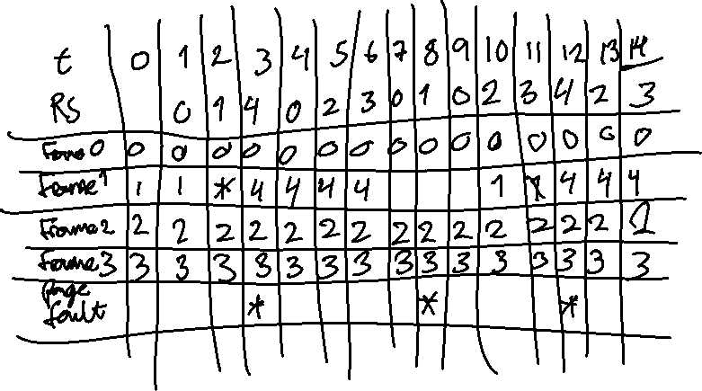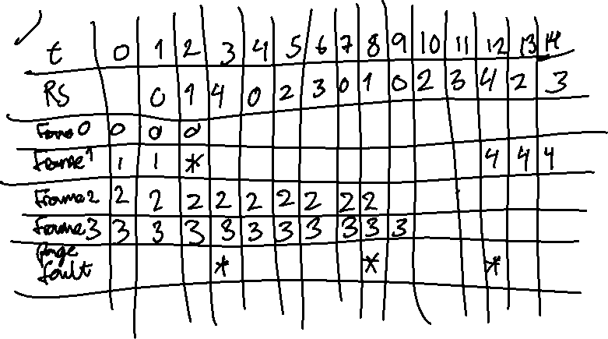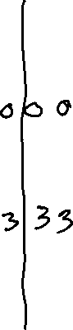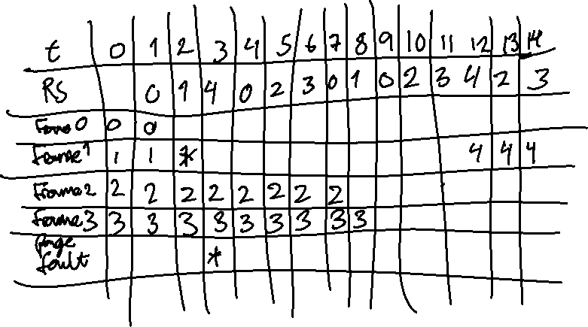

# 7.3.1

Page 0: 00 0111 = 7

Page 1: 10 0000 = 32

Page 2: 01 1000 = 8

Page 3: 00 0010 = 2

Page 3 would be replaced since it has the lowest value

# 7.3.2

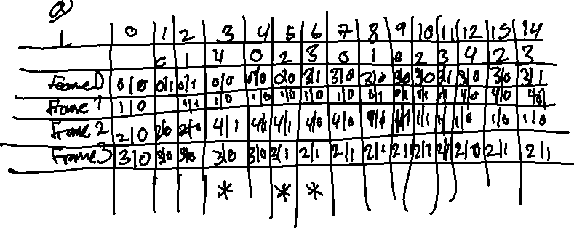

# 7.4.1

a) 38/14 = 2.714



b) 37/14 = 2.643

# 7.4.2

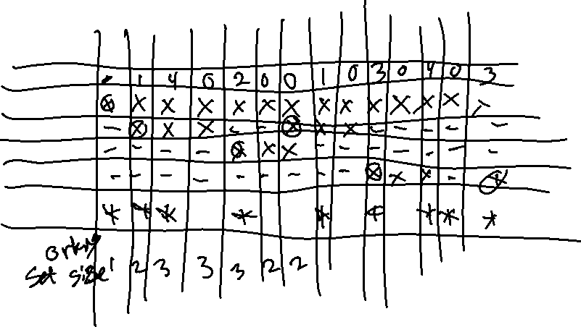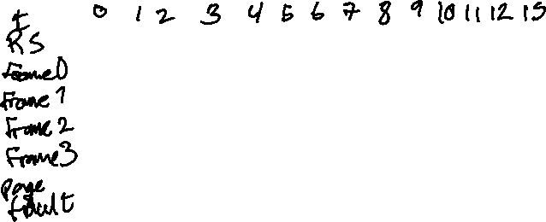

# 7.4.3

a) 6

b) 4

# 7.5.1

N * 5 + (n-1) * 15 = 200 => 5n + 15n – 15 = 200 => n = 10,75

# 7.5.3

a) 10^7 = 100.000.000

b) (1.000.000/1024) * 20 = 19,531